Steps to Arabic – Tutorial Notes
Table of Contents
September 28, 2019 – Letters and Taskheel 3
Typing in Arabic 3
Uthmani v. Newspaper 3
A way to understand the shadda 3
Tajweed signs/rules, not Arabic 3
A note on some letters 3
Homework 4
October 5, 2019 – Word Families, Family II Past Tense 5
Family II – Overview 5
Family II, Past Tense 5
Dictionary Practice 6
Homework – Activity 3 from “Past Tense”, Activity 2 from “Dictionary” 7
October 12, 2019 – Family II 8
Family II – Overview 8
Family II – Activities 8
October 19, 2019 – Family IV and II 10
Family IV and II – Overview 10
Family IV 10
Family II 11
Family II v. Family IV 12
October 26, 2019 – Family I, II and IV 13
Hamzatul Qat’ (قَطْع) 13
Hamzatul Wasl (وصل) 13
The good old ا 13
Summarize the features of I, II and IV 13
November 2, 2019 – Properties of Ism, Review 17
Properties of Ism 18
November 23, 2019 – Surah Mulk Study 19
November 30, 2019 – Mudaf + Surah Mulk Study 21
Review of Mudaf and Mudaf Ilayhi 21
Type of Mudaf 21
Sukoon at the end + beginning of word 22
December 7, 2019 – Surah Mulk Study 23
لَقَدْ 24
لِ Harf Jarr followed by ال Ism Majroor 24
لِ Harf Jarr followed by Pronoun 24
Tanween or the Lack of it 24
Words like مَصَابِيحَ 25
December 14, 2019 – Surah Mulk Study 25
Some words are feminine BASS 26
December 21, 2019 – Surah Mulk Study 27

September 28, 2019 – Letters and Taskheel

Typing in Arabic
https://www.branah.com/arabic

Uthmani v. Newspaper
Uthmani spelling: ءَامَنَ
Newspaper Arabic spelling: آمَنَ
- آ = ءَا
ٱلسَّمَـٰوَٰتِ السماوات
- ٱ = ا
- Little alif = big alif with sukoon

A way to understand the shadda
رَبُّ رَبَّ رَبِّ
رَبُّ = رَبْ بُ
رَبَّ = رَبْ بَ
رَبِّ = رَبْ بِ
Shaddah is the doubling of the letter, not the length of pronunciation
Pronounced twice, but each pronunciation has its own length

Tajweed signs/rules, not Arabic
رَّبِّهِۦ
little tajweed ya is for pronunciation but not equivalent to a ya with sukoon
وَٱلْمُؤْمِنُونَ ۚ
يَشَآءُ

A note on some letters
(ya at the end of a word without dots)فِى = فِي
عَلَىٰ
Alif Maqsoora = alif with sukoon on a ى with no dots
Not a ي, but in fact an اْ
Always has a sukoon on it
Remains as is in newspaper Arabic as well
http://tanzil.net/#87:1
Can I write عَلَى as عَلَا? No
بَعُوضَةً

Homework
Type your name in Arabic in an email and send it to me
Use https://www.branah.com/arabic
OR install Arabic keyboard on your device

October 5, 2019 – Word Families, Family II Past Tense

Family II – Overview
- Past tense: سَلَّمَ He protected from harm
- Present tense: يُسَلِّمُ He protects from harm
- Command tense: سَلِّمْ You, protect from harm!
- The Masdar: التَّسْلِيم The protection from harm
- The Actor: الْمُسَلِّم The protector
- The Acted Upon: الْمُسَلَّم The protected

Family II, Past Tense
Activity 1 – Make the past tense for Family II for the following words and look up the meaning in the dictionary.
Note: Sometimes the endings will change. This is due to some grammar implication. We will learn these later insha Allah.
Meaning | Family II Past Tense | Root Letters
He taught | عَلَّمَ allama | R1ع R2 ل R3 م
He honoured | كَرَّمَ karrama | ك ر م
He made someone enjoy something | مَتَّعَ matta | م ت ع
He made clear | بَيَّنَ bayyana | ب ي ن
He adorned | زَيَّنَ zayyana | ز ي ن
He subjected | سَخَّرَ sakhkhara | س خ ر
 |  | خ ل ف
 |  | ق د ر

Activity 2 – Which of the following is a Family II Past Tense?
- نَزَلَ نَزَّلَ نَزِّلَ أَنْزَلَ
- بَشِّرَ بُشِّرَ بَشَّرَ بَشَرَ
- قَوَمَ قَّوَمَ قَوَّمَ قَوَّمٌ
Activity 3 – Is the following part of Family II or not?
- التَّسْلِيم
- قَدَّرَ
- ذَبَّحَ
- يُبَشِّرُ
- نَزِّلْ
- الْمُبَشِّر

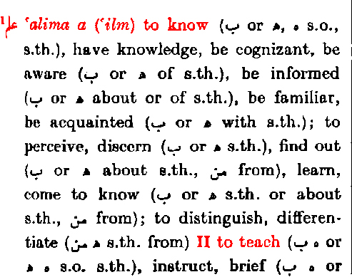
Dictionary Practice

Root Letters: The first part of an entry are the three root letters.
Family I: This is the Past Tense of Family I for the root letters.
Masdar for Family I.
The Meaning: This is for Family I in the form of “to …”.
Family II: The meaning for Family II in the form of “to …”.

Activity 1 – Find the meaning of the rest of the Families for ع ل م in the dictionary.
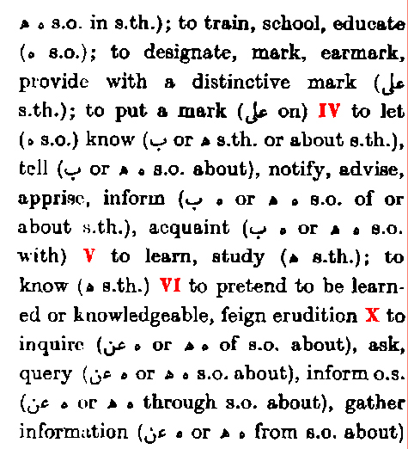

Family | Meaning
IV | He let someone know
V | He learned
VI | He pretended to know
VII | N/A
VIII | N/A
IX | N/A
X | He inquired

Activity 2 – Find the meaning of the Families for خ ل ق (xlK) in the dictionary.
Family I Past Tense |  | Family I Masdar | Family I Meaning
Family | Meaning
II
III
IV
V
VI
VII
VIII
X

Homework – Activity 3 from “Past Tense”, Activity 2 from “Dictionary”

October 12, 2019 – Family II

Family II – Overview
- Past tense: سَلَّمَ He protected from harm
  - R1 fatha + R2 shadda fatha + R3 fatha*
- Present tense: يُسَلِّمُ He protects from harm
  - يُ* + R1 fatha + R2 shadda kasra + R3 dhamma*
- Command tense: سَلِّمْ You, protect from harm!
  - R1 fatha + R2 shadda kasra + R3 sukoon*
- The Masdar: التَّسْلِيم The protection from harm
  - ال* + تَ + R1 sukoon + R2 kasra + يْ + R3*
- The Actor: الْمُسَلِّم The protector
  - ال* + مُ + R1 fatha + R2 shadda kasra + R3*
- The Acted Upon: الْمُسَلَّم The protected
  - ال* + مُ + R1 fatha + R2 shadda fatha + R3*

Family II – Activities
Activity 1 – Label each member of Family II.

يُنَزِّلُ
يُقَدِّمُ
يُبَدِّلُ
نَزِّلْ
نَزَّلَ
قَدِّمْ
قَدَّمَ
عَلِّمْ
عَذِّبْ
عَذَّبَ
سَخَّرَ
بَدِّلْ
بَدَّلَ
يُعَلِّمُ
المُنَزِّل
المُنَزَّل
المُقَدِّم
المُقَدَّم
المُعَلِّم
المُعَلَّم
المُعَذِّب
يُعَذِّبُ
المُعَذَّب
المُبَدِّل
المُبَدَّل
التَّنْزِيل
التَّقْدِيم
التَّعْلِيم
التَّعْذِيب
التَّبْدِيْل

Activity 2 – Make all the family members from Family II from the root letters below:
س خ ر
سَخَّرَ يُسَخِّرُ سَخِّرْ التَّسْخِير المُسَخِّر المُسَخَّر to subject
ك ذ ب
كَذَّبَ يُكَذِّبُ كَذِّبْ التَّكْذِيب المُكَذِّب المُكَذَّب to deny/reject
ن ب ء
نَبَّأَ يُنَبِّأُ نَبِّئْ التَّنْبِيء المُنَبِّئ المُنَبَّأ to inform
س ب ح
سَبَّحَ يُسَبِّحُ سَبِّحْ التَّسْبِيح المُسَبِّح المُسَبَّح to glorify
ح ر م
حَرَّمَ يُحَرِّمُ حَرِّمْ التَّحْرِيم المُحَرِّم المُحَرَّمto forbid
ب ش ر
بَشَّرَ يُبَشِّرُ بَشِّرْ التَّبْشِير المُبَشِّر المُبَشَّر to congratulate
Activity 3 – For any three root letter sequences, find an ayah of the Qur’an. [HOMEWORK]

October 19, 2019 – Family IV and II

Family IV and II – Overview
ن ز ل
أَنْزَلَ يُنْزِلُ أَنْزِلْ الإِنْزَال المُنْزِل المُنْزَل
Prominent features of IV:
- the أ
- the first letter in present tense has a dhamma
نَزَّلَ يُنَزِّلُ نَزِّلْ التَنْزِيل المُنَزِّل المُنَزَّل
Prominent features of II:
- the shadda on R2
- the first letter in present tense has a dhamma
Whenever you see مُ, you have two options:
- It’s the Actor (R2 kasra), OR
- It’s the Acted Upon (R2 fatha)

Family IV
Activity 1 – Fill in the rows according to the pattern.
The Acted Upon | The Actor | The Masdar | Command Tense | Present Tense | Past Tense | Root Letters
المُنْذَر | المُنْذِر | الإِنْذَار | أَنْذِرْ | يُنْذِرُ | أَنْذَرَ | ن ذ ر
المُحْسَن | المُحْسِن | الإِحْسَان | أَحْسِنْ | يُحْسِنُ | أَحْسَنَ | ح س ن
المُفْسَد | المُفْسِد | الإِفْسَاد | أَفْسِدْ | يُفْسِدُ | أَفْسَدَ | ف س د
المُنْفَق | المُنْفِق | الإِنْفَاق | أَنْفِقْ | يُنْفِقُ | أَنْفَقَ | ن ف ق
المُصْلَح | المُصْلِح | الْإِصْلَاح | أَصْلِحْ | يُصْلِحُ | أَصْلَحَ | ص ل ح
المُجْرَم | الْمُجْرِم | الإِجْرَام | أَجْرِمْ | يُجْرِمُ | أَجْرَمَ | ج ر م
الْمُنْكَر | المُنْكِر | الإِنْكَار | أَنْكِرْ | يُنْكِرُ | أَنْكَرَ | ن ك ر
 |  |  |  |  | أَغْرَقَ
 |  |  |  | يُمْسِكُ
 |  | الْإِسْرَاف

Family II
Activity 1 – Fill in the rows according to the pattern.
The Acted Upon | The Actor | The Masdar | Command Tense | Present Tense | Past Tense | Root Letters
المُحَمَّد | المُحَمِّد | التَحْمِيد | حَمِّدْ | يُحَمِّدُ | حَمَّدَ | ح م د
المُسَبَّح | المُسَبِّح | التَسْبِيح | سَبِّحْ | يُسَبِّحُ | سَبَّحَ | س ب ح
المُكَبَّر | المُكَبِّر | التَكْبِير | كَبِّرْ | يُكَبِّرُ | كَبَّرَ | ك ب ر
المُعَرَّف | المُعَرِّف | التَعْرِيف | عَرِّفْ | يُعَرِّفُ | عَرَّفَ | ع ر ف
المُكَلَّم | المُكَلِّم | التَّكْلِيم | كَلِّمْ | يُكَلِّمُ | كَلَّمَ | ك ل م
المُكَرَّم | الْمُكَرِّم | التَكْرِيم | كَرِّمْ | يُكَرِّمُ | كَرَّمَ | ك ر م
الْمُبَشَّر
 |  |  |  |  | قَرَّبَ
 |  |  |  | يُنَزِّلُ
 |  | التَّحْرِيم

مَكة المُكَرَّمَة
المَدِينَة المُنَوَّرَة

Family II v. Family IV
Activity 1 – Which family does each word belong to? You can select II, IV or neither.

- التَّكْسِير
- يُدْرِكُ
- الْمُكَذِّب
- الْمُفْلِح
- بَلِّغْ
- يُجَاهِدُ
- الإِفْطَار
- الْمُقَرَّبُوْنَ
- الاِسْتِكْبَار
- اِجْتَنَبَ
- قَاتِلْ
- الإِكْرَام
- يُرْسِلُ
- أَخْبِرْ
- الْمُبَدِّل
- التَّصْدِيْق
- يَنْفَطِرُ
- الْمُسَافِر
- يُقْبِلُ
- أَسْلِم

October 26, 2019 – Family I, II and IV
Hamza v Hamza v Alif
ء ؤ أ إ ئ
ٱ
ا
بَـٰ = بَا

Hamzatul Qat’ (قَطْع)
The cutting Hamza = ء ؤ أ إ ئ
It’s because the connecting sound is cut off and you pronounce the hamza
Features prominently in Family IV
يُنْزِلُ أَنْزِلْ

Hamzatul Wasl (وصل)
The joining Hamza, pronounced when starting/skipped when joining
In Qur’anic script, written as ٱ
In newspaper Arabic, written as ا
Features in Family I Command
يَنْزِلُ اِنْزِلْ
NOT to be confused with اْ
Also, NOT to be confused with أَ or إِ

The good old ا
اْ or little alif بَـٰ that extends the sound to two units

Summarize the features of I, II and IV
Family I:
- Present tense يَ
- Command Tense always has a Hamzatul Wasl in the beginning
Family II:
- Present tense يُ
- Shadda
Family IV:
- Present tense يُ
- Hamzatul Qat أ إ
- Command Tense always has Hamzatul Qat in the beginning
Activity 1 – Complete the table.
The Acted Upon | The Actor | The Masdar | Command Tense | Present Tense | Past Tense | Family | Root Letters
المَنْزُول | النَازِل | النُزُول | اِنْزِلْ | يَنْزِلُ | نَزَلَ | I | ن ز ل
المُنَزَّل | المُنَزِّل | التَنْزِيل | نَزِّلْ | يُنَزِّلُ | نَزَّلَ | II
المُنْزَل | المُنْزِل | الإِنْزَال | أَنْزِلْ | يُنْزِلُ | أَنْزَلَ | IV
المَسْلُوم | السَالِم | السَلَام  السَلَامَة | اِسْلَمْ | يَسْلَمُ | سَلِمَ | I | س ل م
المُسَلَّم | المُسَلِّم | التَسْلِيم | سَلِّمْ | يُسَلِّمُ | سَلَّمَ | II
المُسْلَم | المُسْلِم | الإِسْلَام | أَسْلِمْ | يُسْلِمُ | أَسْلَمَ | IV
 |  |  |  |  |  | I | *ع ل م
 |  |  |  |  |  | II
 |  |  |  |  |  | IV
 |  |  |  |  |  | I | *ر ج ع
 |  |  |  |  |  | II
 |  |  |  |  |  | IV
 |  |  |  |  |  | I | ء م ن
 |  |  |  |  |  | II
 |  |  |  |  |  | IV

The Acted Upon | The Actor | The Masdar | Command Tense | Present Tense | Past Tense | Family | Root Letters
 |  |  |  |  |  | I | *خ ر ج
 |  |  |  |  |  | II
 |  |  |  |  |  | IV
المَذْكُور | الذَاكِر | الذِكْر  التَذْكَار | اُذْكُرْ | يَذْكُرُ | ذَكَرَ | I | ذ ك ر
المُذَكَّر | المُذَكِّر | التَذْكِير | ذَكِّرْ | يُذَكِّرُ | ذَكَّرَ | II
المُذْكَر | المُذْكِر | الإِذْكَار | أَذْكِرْ | يُذْكِرُ | أَذْكَرَ | IV
 |  |  |  |  |  | I | س م ع
 |  |  |  |  |  | II
 |  |  |  |  |  | IV
 |  |  |  |  |  | I | د ر ج
 |  |  |  |  |  | II
 |  |  |  |  |  | IV
 |  |  |  |  |  | I | ن ع م
 |  |  |  |  |  | II
 |  |  |  |  |  | IV

Activity 2 – Identify the word as Family I, II or IV. Identify Family member as well.

- بَلِّغْ
- الْمُفْلِح
- التَّكْسِير
- يُرْسِلُ
- يُقْبِلُ
- أَسْلِمْ
- الْمُكَذِّب
- الْمُقَرَّبُوْنَ
- النَاصِر
- المَنْصُور
- يَنْصُرُ
- أَخْبِرْ
- يُدْرِكُ
- الْمُبَدِّل
- نَصَرَ
- يُجَاهِدُ
- الإِكْرَام
- الإِفْطَار
- يَفْعَلُ
- اُنْصُرْ
- التَّصْدِيْق
- فَعَلَ
- الفَاعِل
- اِفْعَلْ
- المَفْعُول

Activity 3 – Qur’an Study

http://tanzil.net/#3:41

November 2, 2019 – Properties of Ism, Review
Activity 1 – Review: Complete the table.
The Acted Upon | The Actor | The Masdar | Command Tense | Present Tense | Past Tense | Family | Root Letters
المَسْمُوع | السَامِع | السَمْع | اِسْمَعْ | يَسْمَعُ | سَمِعَ | I | س م ع
المُسَمَّع | المُسَمِّع | التَسْمِيع | سَمِّعْ | يُسَمِّعُ | سَمَّعَ | II
المُسْمَع | المُسْمِع | الإِسْمَاع | أَسْمِعْ | يُسْمِعُ | أَسْمَعَ | IV

Activity 2 – Properties of Ism: Complete the table.
Masculine
Status | Definite |  | Indefinite
 | The one who makes others hear | The two who make others hear | One who makes others hear | Two who make others hear
Marfoo’ مَرْفُوع | المُسْمِعُ | المُسْمِعَانِ | مُسْمِعٌ | مُسْمِعَانِ
Mansub مَنْصُوب | المُسْمِعَ | المُسْمِعَيْنِ | مُسْمِعًا | مُسْمِعَيْنِ
Majroor مَجْرُور | المُسْمِعِ |  | مُسْمِعٍ
Feminine
How to make feminine: ة at the end, R3 fatha
Status | Definite |  | Indefinite
 | The one lady who makes others hear | The two ladies who make others hear | One lady who makes others hear | Two ladies who make others hear
Marfoo’ مَرْفُوع | المُسْمِعَةُ | المُسْمِعَتَانِ | مُسْمِعَةٌ | مُسْمِعَتَانِ
Mansub مَنْصُوب | المُسْمِعَةَ | المُسْمِعَتَيْنِ | مُسْمِعَةً | مُسْمِعَتَيْنِ
Majroor مَجْرُور | المُسْمِعَةِ |  | مُسْمِعَةٍ
أَفْوَاجًا v. حَامِيَةً
Both are Mansub
أَفْوَاجًا is pronounced as afwaajaa أَفْوَاجَا when stopping on it
حَامِيَةً is pronounced hamiyah حَامِيَه when stopping on it

Properties of Ism
- Status – marfoo’, mansub or majroor
- Number – one, pair or (soon we’ll see plural)
- Gender – masculine or feminine
- Type – definite or indefinite
Activity 3 – Qur’an Study: Surah Fatiha.

Activity 4 – Properties of Ism: Complete the table.

TYPE | GENDER | NUMBER | STATUS | ROOT LETTERS | ISM
Indefinite | Masculine | 1 | Marfoo | ع ل م | مُعَلِّمٌ
Definite | Masculine | 2 | Mansub OR Majroor | ك ف ر | الكَافِرَيْنِ
 |  |  |  |  | مُسْلِمِيْنَ
 |  |  |  |  | مُؤْمِنَتَانِ
Indefinite | Feminine | 1 | Mansub | ص ل ح | صَالِحَةً
 |  |  |  |  | الحَافِظَتَيْنِ
 |  |  |  |  | خَاشِعًا
 |  |  |  |  | مُجَاهِدَتَانِ
 |  |  |  |  | مُعَلِّمَتَانِ
 |  |  |  |  | مُقَرَّبًا
 |  |  |  |  | المُرْجِعَةَ
 |  |  |  |  | مَذْكُوْرًا
 |  |  |  |  | سَامِعٍ

November 23, 2019 – Surah Mulk Study
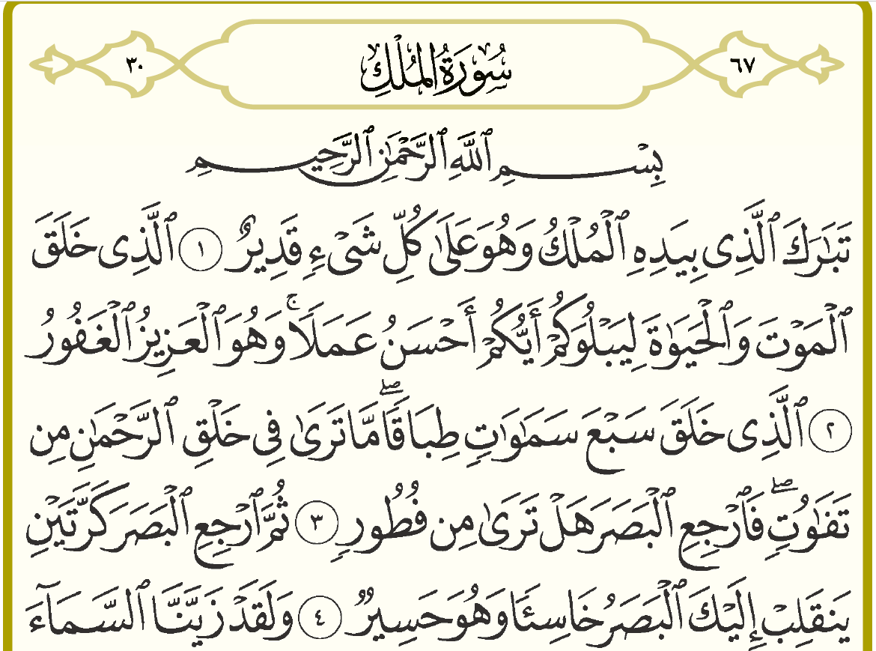
Blessed is the One who in hand his His hand (is) the dominion.
And He (is) over everything All-Powerful.
The One who He created the death and the life so that He may test you which (of) you (is) best (in) deed.
And He (is) the All-Mighty, the Oft-Forgiving.
The One who He created seven skies one above the other.
Not you see You won’t see in the creation (of) the Most Merciful from any fault.
So you, return the vision look again! Do you see from any flaw?
Type | Gender | Number | Status | Meaning | Family Member | Family | Root Letters | Word
Def | Masc | 1 | Marfoo’ | The dominion | Masdar | I | م ل ك | المُلْكُ
Indef | Masc | 1 | Marfoo’ | All-Powerful | N/A | N/A | ق د ر | قَدِيرٌ
N/A | N/A | N/A | N/A | He created | Past Tense | I | خ ل ق | خَلَقَ
Indef | Masc | 1 | Mansub | Deed | Masdar | I | ع م ل | عَمَلًا
Indef | Feminine | Plural | Mansub/  Majroor | Skies | N/A | N/A | س م و | سَمَاوَاتٍ
N/A | Masc | 1 | Majroor | Creation | Masdar | I | خ ل ق | خَلْقِ
N/A | N/A | N/A | N/A | You, return! | Command | I | ر ج ع | ٱرْجِعِ
 |  |  |  |  | N/A | N/A |  | كَرَّتَيْنِ
 |  |  |  |  |  |  |  | خَاسِئًا

November 30, 2019 – Mudaf + Surah Mulk Study

Review of Mudaf and Mudaf Ilayhi
Noال Tanween Majroor
- Mudaf: No ال
- Mudaf: No Tanween
- Mudaf Ilayhi: Majroor

Type of Mudaf
Since Mudaf does not have ال and does not have Tanween, how do you determine its type?
- Type of Mudaf = Type of Mudaf Ilayhi
  - Mudaf Ilayhi is Definite Mudaf is Definite
  - Mudaf Ilayhi is Indefinite Mudaf is Indefinite
كِتَابٌ – A book
مُسْلِمٌ – A Muslim
The book of the Muslim? كِتَابُ المُسْلِمِ
A book of a Muslim? كِتَابُ مُسْلِمٍ
The book of a Muslim? Can’t use M/MI الكِتَابُ لِمُسْلِمٍ The book (is) for a Muslim
A book of the Muslim? Can’t use M/MI كِتَابٌ لِلْمُسْلِمِ A book for the Muslim
حَدِيث – statement رَسُولٌ – messenger
The statement of the messenger – حَدِيثُ الرَسُولِ
A statement of a messenger – حَدِيثُ رَسُولٍ
The statement of a messenger – الحَدِيثُ لِرَسُولٍ
A statement of the messenger – حَدِيثٌ لِلْرَّسُولِ
Blessed is the One who in hand his His hand (is) the dominion.
And He (is) over everything All-Powerful.
The One who He created the death and the life so that He may test you which (of) you (is) best (in) deed.
And He (is) the All-Mighty, the Oft-Forgiving.
The One who He created seven skies one above the other.
Not you see You won’t see in the creation (of) the Most Merciful from any fault.
So you, return the vision look again! Do you see from any flaw?

Sukoon at the end + beginning of word
فَٱرْجِعْ ٱلْبَصَرَ
رَجَعَ يَرْجِعُ ٱرْجِعْ
Can’t have sukoon at the end of 1st word + sukoon at the beginning of 2nd word
When this happens, what changes? The sukoon of the 1st word changes to َ ُ ِ (called harakat).
In this case, kasra فَٱرْجِعِ ٱلْبَصَرَ
مِنْ الْجِنَّةِ مِنَ الْجِنَّةِ
Then you, return! the vision twice again Then look again and again
Will return to you the vision The vision will return to you humbled
And he (is) fatigued And it (is) fatigued.
وَ - Harf
هُوَ – Mubtada
حَسِيرٌ – Khabar
Type | Gender | Number | Status | Meaning | Family Member | Family | Root Letters | Word
Def | Masc | 1 | Marfoo’ | The dominion | Masdar | I | م ل ك | المُلْكُ
Indef | Masc | 1 | Marfoo’ | All-Powerful | N/A | N/A | ق د ر | قَدِيرٌ
N/A | N/A | N/A | N/A | He created | Past Tense | I | خ ل ق | خَلَقَ
Indef | Masc | 1 | Mansoob | Deed | Masdar | I | ع م ل | عَمَلًا
Indef | Feminine | Plural | Mansoob/  Majroor | Skies | N/A | N/A | س م و | سَمَاوَاتٍ
Def | Masc | 1 | Majroor | Creation | Masdar | I | خ ل ق | خَلْقِ
N/A | N/A | N/A | N/A | You, return! | Command | I | ر ج ع | ٱرْجِعِ
Indef | Fem | 2 | Mansoob/  Majroor | Twice again | N/A | N/A | ك ر ر | كَرَّتَيْنِ
Indef | Masc | 1 | Mansoob | Humbled | Actor | I | خ س ء | خَاسِئًا

December 7, 2019 – Surah Mulk Study
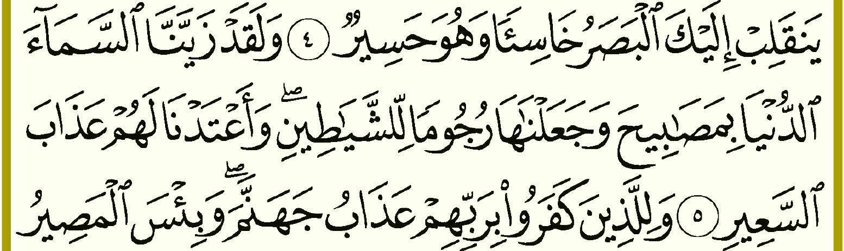
And وَ for sure (I swear) لَقَدْ We have beautified زَيَّنَّا the sky السَّمَاءَ the nearest الدُّنْيَا the nearest sky with بِ lamps مَصَابِيحَ and وَ we made جَعَلْنَا them هَا (as) missiles رُجُومًا for لِ the devils الشَيَاطِينِ.
And وَ we have prepared أَعْتَدْنَا for them لَهُمْ punishment عَذَابَ the blaze السَعِيرِ the punishment (of) the blaze

لَقَدْ
لَقدْ is two Harfs: لَ and قَدْ
Both of these Harfs are for emphasis, but with a small difference
لَ means “Surely, I swear” (not a Harf of Oath). The “I swear” part is called مَحْذُوف omitted from the writing, but included in the meaning.
قَدْ means “For sure”.
قَدْ and لَ only come before a Fi’l. Only emphasizes a Fi’l.

لِ Harf Jarr followed by ال Ism Majroor
لِ + ٱلشَّيَاطِينِ = لِلشَّيَاطِينِ
لِ + ٱلْمُسْلِمِ = لِلْمُسْلِمِ

لِ Harf Jarr followed by Pronoun
لَهُم = for them
We know the word for “for” is لِ
When the word لِ comes before a pronoun – in other words, when a pronoun is attached to the word لِ – the word لِ turns into لَ.
Is it still the same Harf Jarr that means “for”? Yes.
لَهُم = for them
لِلشَّيَاطِينِ = for the devils

Tanween or the Lack of it
An Ism has to have an tanween by default. If you do not see a tanween on an Ism, it can be one of three reasons:
- It has an ال e.g. رَسُولٌ الرَسُولُ
- It is Mudaf e.g. رَسُولٌ رَسُولُ اللهِ
- Words like مَصَابِيحَ.
Excluded from this list are:
- Pronouns + proper nouns (e.g. مُحَمَّدٌ) because they are always definite
- Masculine and Feminine Pairs e.g. رَسُولَانِ المُسْلِمَانِ مُسْلِمَتَينِ because they have a noon in place of a tanween
- Masculine plurals e.g. مُسْلِمُونَ مُسْلِمِينَ because they have a noon in place of a tanween.

Words like مَصَابِيحَ
These words do not take a tanween. In Arabic grammar books, this is called “مَمْنُوع مِنَ الصَّرْفِ” banned from tanween!
A word that can take tanween will have dhamma (Marfoo), fatha (Mansoob) and kasra (Majroor) e.g. رَسُولٌ رَسُولًا رَسُولٍ.
A word that cannot take tanween (banned from tanween) will only have dhamma (Marfoo) and fatha (Mansoob and Majroor), NO KASRA! For example, مَصَابِيحُ مَصَابِيحَ مَصَابِيحَ.

December 14, 2019 – Surah Mulk Study
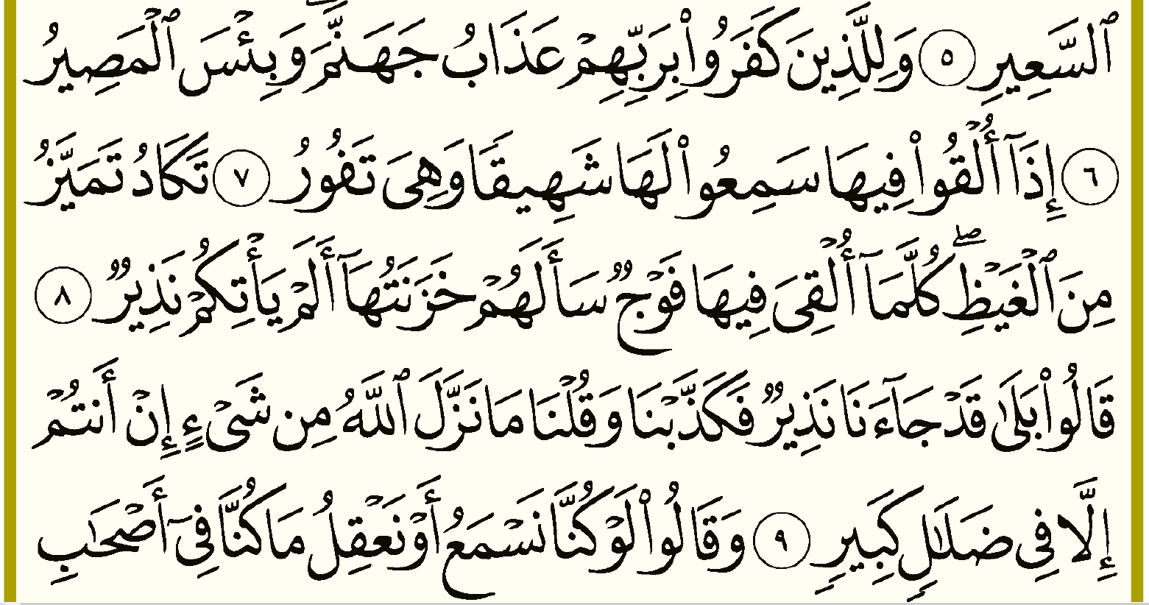
وَ And لِ for ٱلَّذِينَ those who كَفَرُوا disbelieved بِ with/in رَبِّ Lord ـهِمْ their عَذَابُ punishment جَهَنَّمَ hellfire And for those who disbelieved in their Lord (is) the punishment (of) hellfire.
The punishment (of) hellfire (is) for those who disbelieved in their Lord
وَ And بِئْسَ wretched المَصِيرُ the destination What an wretched/evil destination!
إِذَا When أُلْقُوا they are thrown فِي in ـهَا her/it When they are thrown in it (hell)
سَمِعُوا they hear لَ for ـهَا it/her they hear for it (hell)/hear it
شَهِيقًا groaning/inhaling وَ and/while هِيَ she/it تَفُورُ boils up they hear it (hell) groaning/inhaling while it (hell) boils up
تَكَادُ Almost تَمَيَّزُ bursts مِنَ from الغَيظِ the rage It (hell) almost bursts from the rage.
كُلَّمَا every time أُلْقِيَ thrown فِي in ـهَا her/it فَوجٌ a group سَأَلَـ ask ـهُم them خَزَنَتُـ keepers ـهَا her/it every time a group is thrown in it, its (hell’s) keepers ask them
أَ did لَمْ not يَأْتِـ come ـكُمْ you all نَذِيرٌ warner didn’t a warner come to you all?

Some words are feminine BASS
The word جَهَنَّمَ means hell and is feminine. The ayah 7 references جَهَنَّم with a pronoun that is “her”, as there is no “it” pronoun in Arabic.
Why is جَهَنَّم feminine when there is no ة? Because the Arabs Said So (BASS).

December 21, 2019 – Surah Mulk Study
قَالُوا they said بَلَى yes قَدْ surely جَاءَ came ـنَا us came to us نَذِيرٌ a warner a warner came to us
فَ then/but كَذَّبْنَّا we denied وَ and قُلْنَا we said مَا not نَزَّلَ sent down اللهُ Allah مِنْ from شيْءٍ a thing from a thing = anything at all
But we denied and said, “Allah has not sent down anything at all”
إِنْ not أَنْتُمْ you all إلَّا except فِي in ضَلَالٍ error كَبِيرٍ great great error
Not you all except You are in nothing but a great error = You are ONLY in a great error

Activity: for the Fi’l كَذَّبَ, fill out the table below:
The Acted Upon | The Actor | The Masdar | Command Tense | Present Tense | Past Tense | Family | Root Letters
المُكَذَّب | المُكَذِّب | التَكْذِيب | كَذِّبْ | يُكَذِّبُ | كَذَّبَ | 2 | ك ذ ب

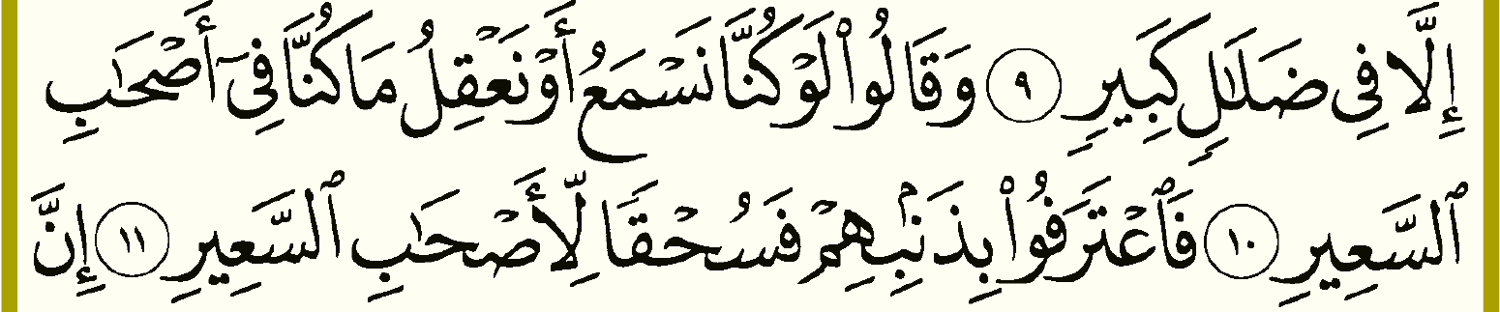
وَ And قَالُوا they said لَوْ if كُنَّا we had نَسْمَعُ listened أو or نَعْقِلُ reasoned مَا not كُنَّا we had فِي in أصْحَابِ companions السَعِيرِ the blaze
And they said (i.e. they will say), “If we had listened or reasoned, we wouldn’t be in (i.e. with/of) the companions of the blaze”
أصْحَابِ: Majroor, plural, masculine, same as mudaf Ilayhi
السَعِيرِ: Majroor, 1, feminine (BASS), definite
فَـ then اعْتَرَفُوا they confess بِـ with/in ـذَنْبـِ sin ـهِمْ them/their their sin
فَ then سُحْقًا away with لِـ for أَصْحَابِ the companions السَعِيرِ the blaze the companions of the blaze

