November 9, 2019 – Properties of Ism, Review
Activity 1 – Review: Complete the table.
The Acted Upon | The Actor | The Masdar | Command Tense | Present Tense | Past Tense | Family | Root Letters
 |  |  |  |  |  | I | ج م ع
 |  |  |  |  |  | II
 |  |  |  |  |  | IV

Activity 2 – Properties of Ism: Complete the table, including looking up the meaning of the word.
صَادِق
Masculine
Status | Definite |  |  | Indefinite
 | <Meaning>
Marfoo’ مَرْفُوع
Mansub مَنْصُوب
Majroor مَجْرُور
Feminine
Status | Definite |  |  | Indefinite
 | <Meaning>
Marfoo’ مَرْفُوع
Mansub مَنْصُوب
Majroor مَجْرُور

Activity 3 – Properties of Ism: Complete the table, including creating the word and looking up the meaning of the word.
Family I Actor from root letters ص ل ح
Masculine
Status | Definite |  |  | Indefinite
 | <Meaning>
Marfoo’ مَرْفُوع
Mansub مَنْصُوب
Majroor مَجْرُور
Feminine
Status | Definite |  |  | Indefinite
 | <Meaning>
Marfoo’ مَرْفُوع
Mansub مَنْصُوب
Majroor مَجْرُور

Activity 4 – Qur’an Study: Fill in the table for the highlighted words.
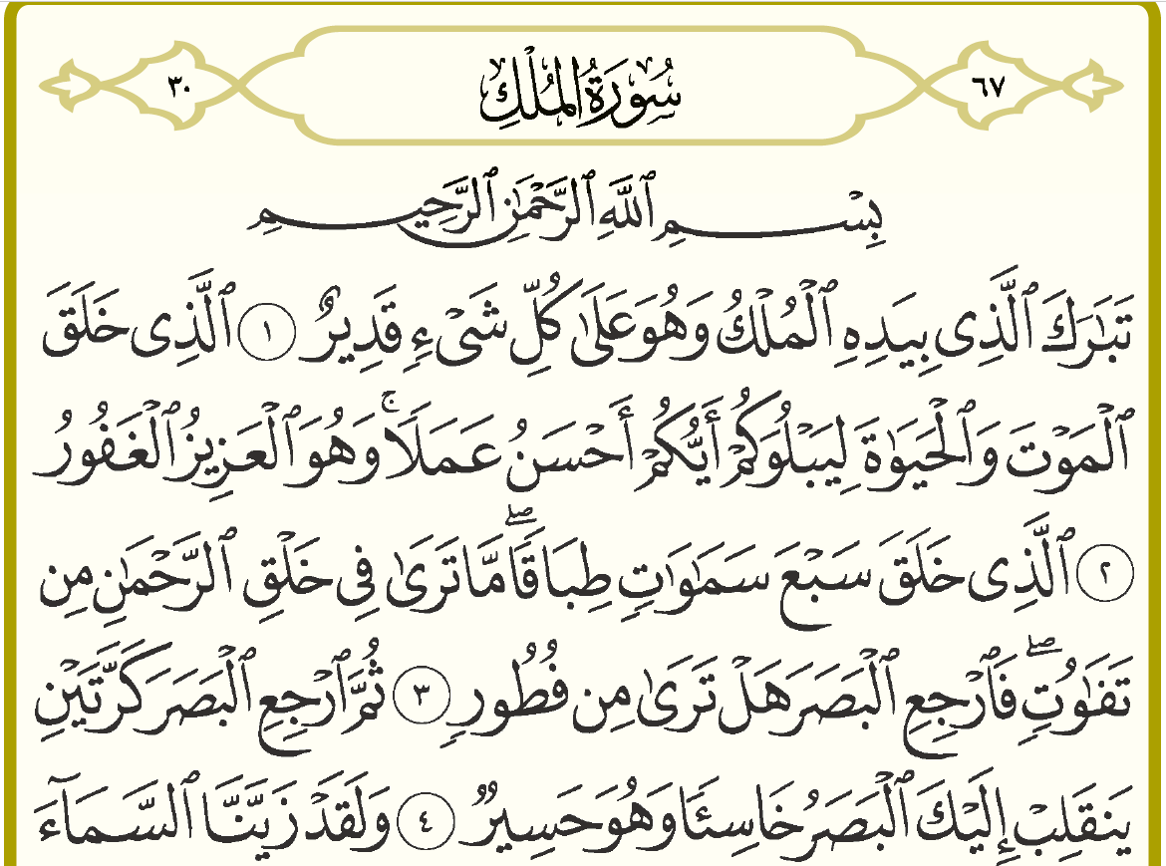
Type | Gender | Number | Status | Meaning | Family Member | Family | Root Letters | Word
 |  |  |  |  | N/A | N/A |  | المُلْكُ
 |  |  |  |  | N/A | N/A |  | قَدِيرٌ
N/A | N/A | N/A | N/A |  |  |  |  | خَلَقَ
 |  |  |  |  | N/A | N/A |  | عَمَلًا
 |  |  |  |  | N/A | N/A |  | سَمَاوَاتٍ
 |  |  |  |  |  |  |  | خَلْقِ
N/A | N/A | N/A | N/A |  |  |  |  | ٱرْجِعِ
 |  |  |  |  | N/A | N/A |  | كَرَّتَيْنِ
 |  |  |  |  |  |  |  | خَاسِئًا

