October 5, 2019 – Letters and Taskheel

Family II – Overview
- Past tense: سَلَّمَ He protected from harm
- Present tense: يُسَلِّمُ He protects from harm
- Command tense: سَلِّمْ You, protect from harm!
- The Masdar: التَّسْلِيم The protection from harm
- The Actor: الْمُسَلِّم The protector
- The Acted Upon: الْمُسَلَّم The protected

Family II, Past Tense
Activity 1 – Make the past tense for Family II for the following words and look up the meaning in the dictionary.

Meaning | Family II Past Tense | Root Letters
 |  | R1ع R2 ل R3 م
 |  | ك ر م
 |  | م ت ع
 |  | ب ي ن
 |  | ز ي ن
 |  | س خ ر
 |  | خ ل ف
 |  | ق د ر

Activity 2 – Which of the following is a Family II Past Tense?
- نَزَلَ نَزَّلَ نَزِّلَ أَنْزَلَ
- بَشِّرَ بُشِّرَ بَشَّرَ بَشَرَ
- قَوَمَ قَّوَمَ قَوَّمَ قَوَّمٌ
Activity 3 – Is the following part of Family II or not?
- التَّسْلِيم
- قَدَّرَ
- ذَبَّحَ
- يُبَشِّرُ
- نَزِّلْ
- الْمُبَشِّر

Dictionary Practice
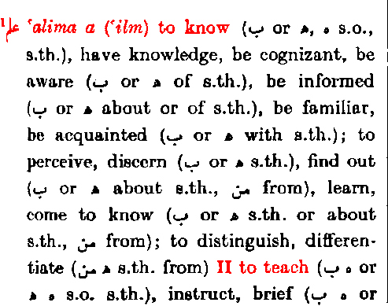

Root Letters: The first part of an entry are the three root letters.

Family I: This is the Past Tense of Family I for the root letters.
Masdar for Family I.
The Meaning: This is for Family I in the form of “to …”.
Family II: The meaning for Family II in the form of “to …”.

Activity 1 – Find the meaning of the rest of the Families for ع ل م in the dictionary.
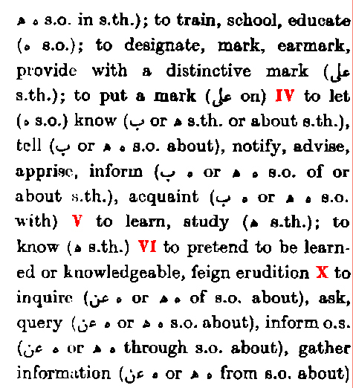

Family | Meaning
IV
V
VI
VII
VIII
IX
X

Activity 2 – Find the meaning of the Families for خ ل ق in the dictionary.
Family I Past Tense |  | Family I Masdar | Family I Meaning
Family | Meaning
II
III
IV
V
VI
VII
VIII
X

